|  |  |
| --- | --- |
| **Roll No.: A046** | **Name: TEJAS PADMAKAR** |
| **Prog/Yr/Sem: 2** | **Batch: 2** |
| **Date of Experiment: 17/02/25** | **Date of Submission: 20/02/25** |

**Lab 6**

**Write PL/SQL function for following:**

1. Factorial of the number

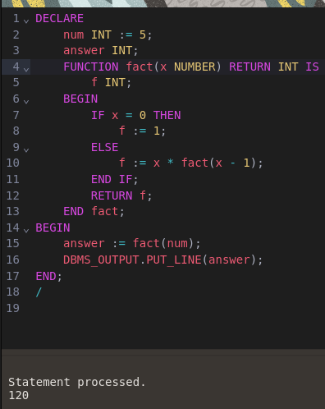

1. Fibonacci series

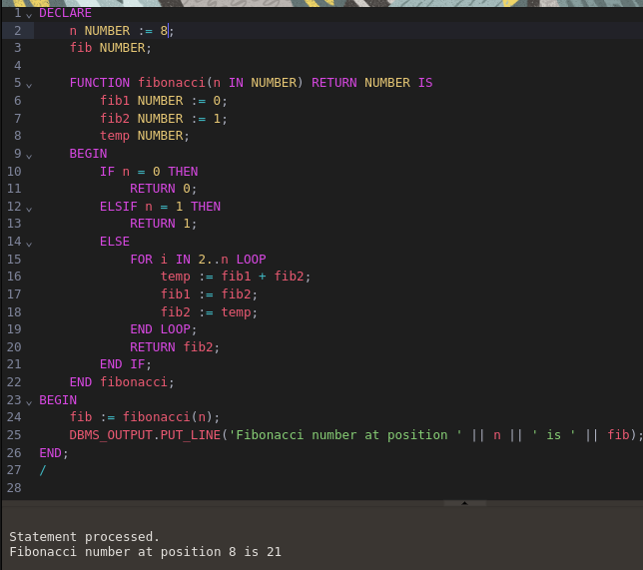

1. If number is Positive, Negative or Zero

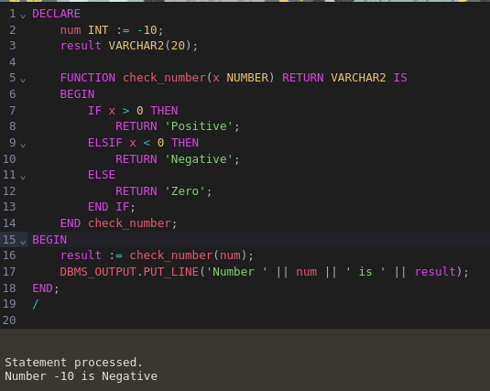

1. Minimum/maximum number from given 3 numbers

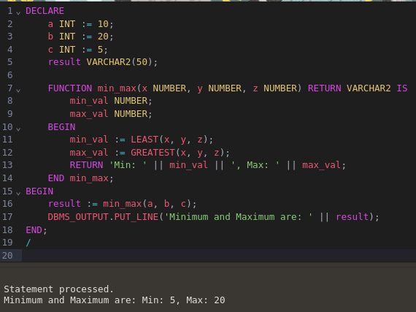

1. Leap year

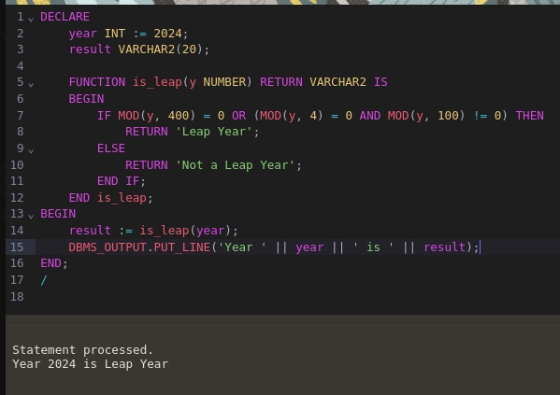

1. Perform following using switch case

* Area of circle
* Area of rectangle
* Area of triangle
* Area of square

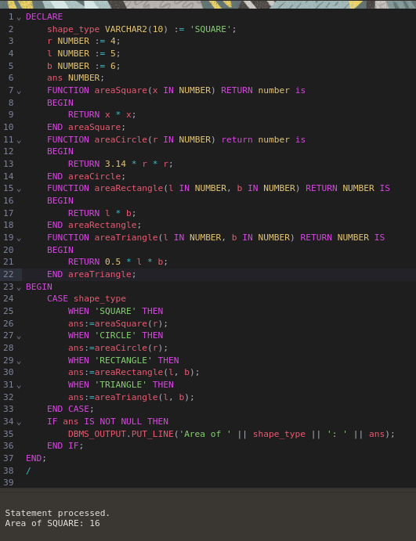

1. Perform following using switch case

* Square of number
* Half value of number
* Square root of number
* Cube of number

